Software Requirements Specification
for
Bugger
Version 1.0 approved
Prepared by Joel Satkauskas

19/11/19
Table of Contents
Table of Contents ii
Revision History ii
1. Introduction 1
1.1 Purpose 1
1.2 Document Conventions 1
1.3 Intended Audience and Reading Suggestions 1
1.4 Product Scope 1
1.5 References 1
2. Overall Description 2
2.1 Product Perspective 2
2.2 Product Functions 2
2.3 User Classes and Characteristics 2
2.4 Operating Environment 2
2.5 Design and Implementation Constraints 2
2.6 User Documentation 2
2.7 Assumptions and Dependencies 3
3. External Interface Requirements 3
3.1 User Interfaces 3
3.2 Hardware Interfaces 3
3.3 Software Interfaces 3
3.4 Communications Interfaces 3
4. System Features 4
4.1 System Feature 1 4
4.2 System Feature 2 (and so on) 4
5. Other Nonfunctional Requirements 4
5.1 Performance Requirements 4
5.2 Safety Requirements 5
5.3 Security Requirements 5
5.4 Software Quality Attributes 5
5.5 Business Rules 5
6. Other Requirements 5
Appendix A: Glossary 5
Appendix B: Analysis Models 5
Appendix C: To Be Determined List 6

Revision History
Name | Date | Reason For Changes | Version

Introduction

Purpose
<Identify the product whose software requirements are specified in this document, including the revision or release number. Describe the scope of the product that is covered by this SRS, particularly if this SRS describes only part of the system or a single subsystem.>

The purpose of this software is to track bugs of a particular project as well as define tasks for that project which can be dragged between different states of progress.

Intended Audience and Reading Suggestions
<Describe the different types of reader that the document is intended for, such as developers, project managers, marketing staff, users, testers, and documentation writers. Describe what the rest of this SRS contains and how it is organized. Suggest a sequence for reading the document, beginning with the overview sections and proceeding through the sections that are most pertinent to each reader type.>

This document is intended for anyone related to the development, management and deployment of the project. This can include software developers, software testers, product owners, project managers.

Product Scope
<Provide a short description of the software being specified and its purpose, including relevant benefits, objectives, and goals. Relate the software to corporate goals or business strategies. If a separate vision and scope document is available, refer to it rather than duplicating its contents here.>

The intendant software allows its user to create and view projects and each project has a Kanban board where the user can create, manage, edit and delete tasks and bugs from that board relate to that project.

Its purpose is to be used by anyone related to the development of a software product to be able to create and keep track of tasks and bugs of that project.

Overall Description

Product Perspective
<A simple diagram that shows the major components of the overall system, subsystem interconnections, and external interfaces can be helpful.>

This project is a self-contained product and not an extension or a follow-up member of any project.

Product Functions
- Guest can login as a User of the system
- Guest and Users can see all the projects that are currently available.
- Guest and Users can see the Kanban board for every project.
- Guests and Users can see comments on a task.
- Users can create, delete and edit projects.
- Users can create, delete and edit columns.
- Users can create, delete and edit tasks.
- Users can make comments on a task.
- Users can drag task from one column to the other.

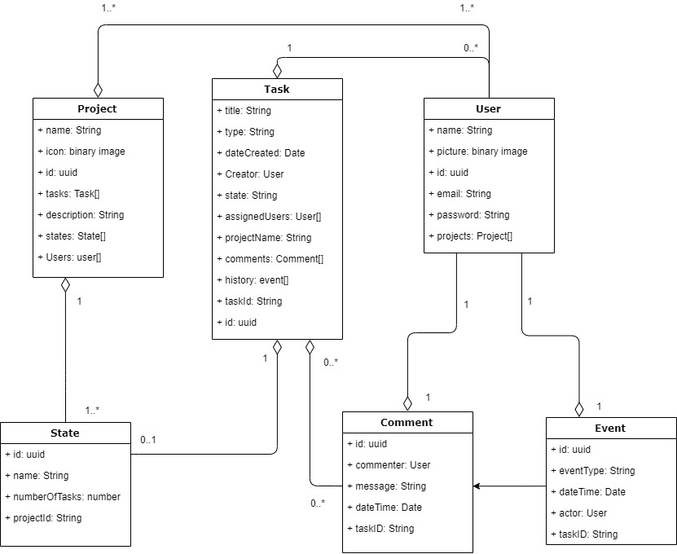

User Classes and Characteristics
<Identify the various user classes that you anticipate will use this product. User classes may be differentiated based on frequency of use, subset of product functions used, technical expertise, security or privilege levels, educational level, or experience. Describe the pertinent characteristics of each user class. Certain requirements may pertain only to certain user classes. Distinguish the most important user classes for this product from those who are less important to satisfy.>

As of version 1 there are only 2 user classes for the Bugger.

- The first is the Guest who would be a visitor to the site and may be interested to view the functionality, look and feel and get a general idea of the application. These users would mainly be recruiters or people in the position of finding and recruiting software engineers/developers for their organization.

- The second user class is the actual User of the software. In theory this would be any individual who participates in the development of the software product that the board would be used for. This may include, but is not limited to, software engineers, developers, software testers, UI/UX designers, scrum masters, product owners, line managers, translators, Development and operations, etc.

Ideally there would be different account types for all of these users but version 1 will only contain one type of user who an individual of any role can be. This User class will be able to access the Kanban board of their project and perform CRUD operations on the columns, tasks and other projects. They can also make comments but cannot delete or modify them. More functionality to this user will be added in future iterations of the software.

The technical expertise of both of these user classes is expected to be quite high and it is expected that they are already familiar with a similar piece of software as it is highly likely they would use such software in their daily activities.

These are the 2 first user classes that the software will support. In future versions there very well may be additional user classes who will work similarly as the current User class.

Operating Environment
This software will be hosted online and will be accessible from any web browser. Chrome will be the primary supported browser and desktop computers, laptops, tablet devices and mobile phones will be the physical devices that users will use to access the site therefore it should possess a visually scalable design.

The other aspects of the application will also be web services so a consistent web connection is required to use the application.

Generally speaking the software would be used in a working environment but has the capacity to be accessible from almost any device and at any time meaning users may use it whenever they wish.

Design and Implementation Constraints
The only limitation to this application is that it must run on the web meaning no language or technology that is used for desktop development can be used.

With this it inherits any limitations that are currently present in the web and its technologies.

Assumptions and Dependencies
<List any assumed factors (as opposed to known facts) that could affect the requirements stated in the SRS. These could include third-party or commercial components that you plan to use, issues around the development or operating environment, or constraints. The project could be affected if these assumptions are incorrect, are not shared, or change. Also identify any dependencies the project has on external factors, such as software components that you intend to reuse from another project, unless they are already documented elsewhere (for example, in the vision and scope document or the project plan).>

It is assumed that:

- The authentication functionality will be taken care of by a 3rd party web API.
- That a framework will be used for both backend and frontend development.
- That the resulting association of components making up the application will be hostable on the web and be scalable.
- That development will be test driven.
- That the project management will be Agile.

External Interface Requirements

User Interfaces
<Describe the logical characteristics of each interface between the software product and the users. This may include sample screen images, any GUI standards or product family style guides that are to be followed, screen layout constraints, standard buttons and functions (e.g., help) that will appear on every screen, keyboard shortcuts, error message display standards, and so on. Define the software components for which a user interface is needed. Details of the user interface design should be documented in a separate user interface specification.>

The following is a look at each interface between the user and the software.

- Landing Page

This is the main page that will display when the URL for the site is entered. This page will function as an introduction to the application as well as an about page for the application. It will possess some information dedicated to the Guest user, who will represent recruiters, of which they might find insightful.

From this page there should be easy access to the rest of the functionality of the application.
2. Login Page

3. Project Page

4. Project Page – Editing

5. Task Page

6. Task Page – Editing

The GUI standard will be made up from the CSS frame work, Bootstrap. Since this is a demonstration project and a unique and expensive GUI is not needed but a general idea of the layout would be good to have therefore a simple and basic approach will be used that primarily involves Bootstrap and its general look and feel.

This framework will also be used to make the pages responsive which will allow the application to be presentable and usable on a device of any screen resolution especially tablets and phones.

In regard to the task page, this may prove difficult to implement a usable interface on a mobile device given the nature of a Kanban board.

Some standards that should be followed:

- Every page should possess a navigation bar that will link all pages together and give a sense of structure. The navigation bar should indicate the current page that the user is on.
- Messages to the user about updates should be in the form of toaster messages or messages following a progress loading segment.
- If a user of the site doesn’t have access to editing privileges, then the editing options should be disabled and a mouse popup should come up explaining this.
- Errors should handle gracefully and attempt to recover. For example if after the user has changed the text and clicked save, if it fails to save it should not close and loose the progress the user has made.

Software Interfaces
<Describe the connections between this product and other specific software components (name and version), including databases, operating systems, tools, libraries, and integrated commercial components. Identify the data items or messages coming into the system and going out and describe the purpose of each. Describe the services needed and the nature of communications. Refer to documents that describe detailed application programming interface protocols. Identify data that will be shared across software components. If the data sharing mechanism must be implemented in a specific way (for example, use of a global data area in a multitasking operating system), specify this as an implementation constraint.>

Communications Interfaces
<Describe the requirements associated with any communications functions required by this product, including e-mail, web browser, network server communications protocols, electronic forms, and so on. Define any pertinent message formatting. Identify any communication standards that will be used, such as FTP or HTTP. Specify any communication security or encryption issues, data transfer rates, and synchronization mechanisms.>

System Features
<This template illustrates organizing the functional requirements for the product by system features, the major services provided by the product. You may prefer to organize this section by use case, mode of operation, user class, object class, functional hierarchy, or combinations of these, whatever makes the most logical sense for your product.>

System Feature 1
<Don’t really say “System Feature 1.” State the feature name in just a few words.>
4.1.1 Description and Priority
<Provide a short description of the feature and indicate whether it is of High, Medium, or Low priority. You could also include specific priority component ratings, such as benefit, penalty, cost, and risk (each rated on a relative scale from a low of 1 to a high of 9).>
4.1.2 Stimulus/Response Sequences
<List the sequences of user actions and system responses that stimulate the behavior defined for this feature. These will correspond to the dialog elements associated with use cases.>
4.1.3 Functional Requirements
<Itemize the detailed functional requirements associated with this feature. These are the software capabilities that must be present in order for the user to carry out the services provided by the feature, or to execute the use case. Include how the product should respond to anticipated error conditions or invalid inputs. Requirements should be concise, complete, unambiguous, verifiable, and necessary. Use “TBD” as a placeholder to indicate when necessary information is not yet available.>

<Each requirement should be uniquely identified with a sequence number or a meaningful tag of some kind.>

REQ-1:
REQ-2:

System Feature 2 (and so on)

Other Nonfunctional Requirements

Performance Requirements
<If there are performance requirements for the product under various circumstances, state them here and explain their rationale, to help the developers understand the intent and make suitable design choices. Specify the timing relationships for real time systems. Make such requirements as specific as possible. You may need to state performance requirements for individual functional requirements or features.>

Safety Requirements
<Specify those requirements that are concerned with possible loss, damage, or harm that could result from the use of the product. Define any safeguards or actions that must be taken, as well as actions that must be prevented. Refer to any external policies or regulations that state safety issues that affect the product’s design or use. Define any safety certifications that must be satisfied.>

Security Requirements
<Specify any requirements regarding security or privacy issues surrounding use of the product or protection of the data used or created by the product. Define any user identity authentication requirements. Refer to any external policies or regulations containing security issues that affect the product. Define any security or privacy certifications that must be satisfied.>

Software Quality Attributes
<Specify any additional quality characteristics for the product that will be important to either the customers or the developers. Some to consider are: adaptability, availability, correctness, flexibility, interoperability, maintainability, portability, reliability, reusability, robustness, testability, and usability. Write these to be specific, quantitative, and verifiable when possible. At the least, clarify the relative preferences for various attributes, such as ease of use over ease of learning.>

Business Rules
<List any operating principles about the product, such as which individuals or roles can perform which functions under specific circumstances. These are not functional requirements in themselves, but they may imply certain functional requirements to enforce the rules.>

Other Requirements
<Define any other requirements not covered elsewhere in the SRS. This might include database requirements, internationalization requirements, legal requirements, reuse objectives for the project, and so on. Add any new sections that are pertinent to the project.>
Appendix A: Glossary
<Define all the terms necessary to properly interpret the SRS, including acronyms and abbreviations. You may wish to build a separate glossary that spans multiple projects or the entire organization, and just include terms specific to a single project in each SRS.>
Appendix B: Analysis Models
<Optionally, include any pertinent analysis models, such as data flow diagrams, class diagrams, state-transition diagrams, or entity-relationship diagrams.>
Appendix C: To Be Determined List
<Collect a numbered list of the TBD (to be determined) references that remain in the SRS so they can be tracked to closure.>

